**INTRODUCTION**

Every day, at least one child dies from a home fire and another 293 children are injured from fires or burns. Ninety percent of all fire-related deaths are due to home fires. Home fires can spread rapidly and leave families as little as two minutes to escape after an alarm sounds (Safe Kids, 2013). This fact has really motivated us in doing this project because safety of children is paramount important to any stakeholders. Children are the future of our nation and their care and safety is in our hand.

The main aim of our project is to find out if mobile games on fire safety will be able to maximize fire safety awareness in kids. Our aim can be achieved by the objectives we have for our project. One of the objectives is designing of an interactive game and secondly implementation of the design on a mobile platform. We will also be researching similar related games on Fire Safety and finding out about their Pros & Cons.

Our report also consists of literature review based on our topic. This section highlights and analyses other fire safety android apps developed for mobile development. The functionalities of current fire safety apps are also briefly explained, and their strengths and weaknesses identified. To be exact, a table at the end of this section will provide all relevant details and functionalities of these apps.

When any project is being carried out there must be a clear purpose for the team members to reach and achieve all the goals of their project. The MOV for our project is the impact of mobile game on kids. We are going to design a fire safety game which will enable the kids to play every now and then and fire safety. Kids remember better by seeing things happening around them and by doing it themselves. The implementation of this game will have greater impact on kids and will bring fire safety awareness. Generally, the community will also benefit from this project as this will enhance the safety of their own kids.

**Problem**

According to (New Zealand Fire Service – “Get Out! Stay Out! Educators’ Guide”), “Children are the most at risk of dying or being badly burned in a fire. They are the most vulnerable because they do not know how to escape a fire safely. We often see that children are not taught the proper way of fire safety. Nowadays parents don’t have time to teach their children and even practice fire safety drills in their homes because of the commitments they have in their daily life’s.

Even when parents send children to school they never bother to find out the fire safety facilities available at that school. ( Thomas Cunningham 1988) “As parents of school age children, and also as emergency service personnel, maybe we need to take an active role in ensuring that are children have a safe learning environment.” Many schools have fire safety procedures but how effectively it is maintained we need to find that. Many places fire exist doors malfunctions, alarm doesn’t work etc and life of our precious children are at risk. When a fire strikes, it spreads extremely rapidly, leaving less than three minutes to get out of a house. All too often, children perish in fires because they hide in cupboards and under beds to escape it. These tragedies can be avoided through fire-safety education. Children can quickly adapt their behavior and influence parents/caregivers to be more conscious of fire safety.” “Over one third of fatalities among the under-fives were the result of the children gaining access to lighters and/or matches. Young children involved in fire ignition are more likely to hide rather than flee from the fire.”

**General Information Which Motivated us to do this project**

How big is the problem of children playing with fire?

• Unintentional injuries are the leading cause of death to pre-school children, accounting for nearly 40% of all deaths in this age group (That’s two and one-half times the second leading cause: cancer) (Source: CDC WISQARS 10/2015 using 2013 data)

• Fire related deaths account for 1 in 8 (23.3%) unintentional injury deaths among preschool children ages 3 to 5 (Source: CDC WISQARS 10/2015 using 2013 data)

• Children playing leads to 49,300 reported fires every year; 7,700 of these at home; 1 in 8 of these residential fires kills or injures someone (Source: NFPA Playing with Fire 3/2014)

• Over 50% of all children experiment with matches or lighters by the time they reach age 13. (Source: Grolnick et al. 1991)

From <http://playsafebesafe.com/why-fire-safety-education/>

**Measurable Organizational Value (MOV)**

When any project is being carried out there must be a clear purpose for the team members to reach and achieve all the goals of their project. To achieve the MOV the members need to work towards the area of the impact, benefits of impact and developing suitable prototype.

The MOV for our project is the impact and benefits of mobile game on kids. The implementation of this game will have social impact on kids and will bring fire safety awareness. Generally, the community will also benefit from this project as this will enhance the safety of their own kids.

**Aim:**To investigate whether a mobile game on fire safety will be able to maximize fire safety awareness among kids at Primary schools, Kindergartens and Child care centers.  
  
 **Objectives:**   
1. Designing of an interactive & Addictive game

2. Research similar related games on Fire Safety and find out about their Pros & Cons

3.Implementing of the design on a mobile platform using Android Studio.

**Current Situation and Purpose**

 Nobody knows when a fire would start. It is something unexpected, but it happens and so many lives are lost. This has motivated us to do a project on Fire safety. This research mostly targets the kids from the age of 5-7. In kindergartens and child care centres a lot care and safety are important for the young ones. According to Thomas Cunningham (US Naval Academy Fire Department) children are very curios and play with fire at some point and surprisingly they have easy access to matches and lighters. They have no idea of the power of one match, what burns and how rapidly fire spreads.(Source: Fireproof Children) In case of a fire at schools and homes, we have seen a lot of children get hurt and some even get seriously injured in the process of saving themselves. Mobile app would be the ideal solution as it is used frequently by several kids today. Using our app, Kids will learn a lot about fire safety and they will know what to do next time a fire starts, or whenever they are around fire. A few minutes playing using this app everyday may save a lot of lives later.

**Scope in our project**

In this project our scope is to maximize fire safety awareness amongst kids aged 5-7 by creating a mobile game. Kids remember better by watching and even by doing it practically. Practice makes a person perfect. The rapid growth in the number of casualties of fire cases worldwide necessitates us developing a mobile game which will easily and effectively maximize fire safety amongst the kids. Designing and implementing of an interactive game on mobile platform will enhance awareness of fire safety amongst kids and will have social impact widely. As per current technology mobile game can be considered as a powerful tool to spread fire safety. Fire safety is something that every individual needs to consider seriously. While playing this game the player will learn fire safety information. At the end of the game the player will gain knowledge about fire safety and should be able to save himself in case of a fire.

**LITERATURE REVIEW**

This section highlights and analyses other fire safety android apps developed for mobile development. The functionalities of current fire safety apps are also briefly explained, and their strengths and weaknesses identified. To be exact, a table at the end of this section will provide all relevant details and functionalities of these apps.

**First App – Lift Safety for Kids**  
Lift Safety for Kids is a android game developed in Ahmedabad, India. This app is only available on the play store It is developed by GameiCreate company to teach young kids all the lift safety tips. App is aimed at kids 8 years and under. The game offers different types of levels. There are more than 5 different levels for kids to enjoy. In the first level kids will learn that if the elevator is full, they would need to wait for the next one. In all levels, the game will have one right answer and one wrong answer. If the wrong answer is chosen, then a message box will appear saying that its wrong and will tell you to choose again. If right answer is chosen, then you proceed to the next level and so on. The App has a great GUI suitable for younger children. It is a great game for kids to learn tons of safety tips in a fun way. App has 1 million downloads and a rating of 4.1 by the users which means that this app has been loved by many children. Even though the game has gotten mainly positive reviews, one negative review about this app is that some users still suggest if the game could have had more levels rather than only 10 to make the game more challenging and enjoyable.   
  
**Second App- Fire Safety for Kids**  
The fire safety game was developed by Kenoobi group. This app is only available on the play store. It is designed to teach Kids about fire safety and how to avoid them when fire situation arises. The game provides a series of quizzes and 3 different levels. First level will ask you to spot 8 different hazards which are available in the room, second level will ask you to guess the cause of fire by showing a picture and third level will teach you how to escape. The game has received a rating of 4 stars by the users but only managed to get 100 downloads which is very less. The good thing about this game is that it is user friendly. Really easy to use if you are a beginner, also the instructions are clear and precise. The GUI is nice and visually appealing. Very suitable for Kids. The pros about this game is that it offers kids 3 different levels to play from. This means that the app offers variety and not just dependable on one situation. Negatives about this app is that it is not very large, which means it doesn’t include that many levels. Once you play spot the hazards, then you must go to a different level either guess the cause of fire or Escape planning quiz. The app should have included maybe few more rounds where you must spot 8 different hazards or something like that. If a kid plays this game, then it will only take about 10 minutes just to play and finish the whole game. Overall the game is fun for little children but if they had more levels then it could’ve been much better. This way kids would be more engaged in the game and the developer of the game would benefit more by the number of downloads and reviews.  
  
**Third App – Safety for Kid – Section 1**

This app teaches kids basic safety knowledge and first aid procedure in emergency. It is developed by Mage Studio – Kid Game. This app is only available on the play store. It is developed in Vietnam. This game has 12 mini games inside them. They include What would you do if a stranger knock, earthquake, lift trouble, tsunami, fire escape and more. The great thing about this app is that it has all types of safety for kids in one app itself. The app has managed to get a rating of 4.7 by the users. It is aimed at kids 8 years of age and under. The GUI of this game is visually appealing with the great use of colours and very suitable for young kids. Game is simple, and the procedures are easy to follow. The app has 2 languages to choose from (Chinese and English) Though the game has many positive reviews, it still has some negative things about it. You must pay to unlock some certain stages. Only 3 stages are free which is not very good. The app has in app purchases. Users suggest that the app should’ve let kids play all the levels for free without paying. More people would download the game if it was free therefore it would benefit the kids and the company.

**Fourth App - Fire Safety E learning**Fire Safety E-Learning app is developed by e-Learning WMB. This app is available on the play store and apple store. The app was developed in England and has over 5 thousand downloads. The app has manged to get a rating of 4.6. The app targets generally adults about fire safety. This app gives you information on five different topics. They are: Why is fire safety so important, Common causes of fire, responsible person and fire risk assessments. Good thing about this app is that there is an audio option which you can choose. This enables users to hear everything instead of reading it. If you are travelling or in a situation where you don’t feel like reading, you can simply choose the audio option to have it read it out to you. The app consists of really important information which can be very useful to everyone. The GUI is alright and easy to follow. One thing I noticed is, it is hard to find the menu button. The menu button is small, and you can barely see it on the screen. Not only the menu button, some other buttons are small which makes it hard for users to navigate through the pages. The app has animations of pictures such as fire to make it visually appealing to the users when they browse through the game. However, this is only the free version of the app, if you want to know more about fire safety and the correct procedures then you will need to buy the pro version of the app from the play store. If only the whole app was free, then it would’ve managed to get more downloads.

**Fifth App – Help Mikey**This app is called Fire Safety- Help Mikey, developed by Animatus Studio. This app teaches little kids what to do in case of a fire at your house. It tells kids the right procedures to follow to get out of the house. The alarm rings at the start and you as a kid must select the right option given. There will be 3 choices and you must select which one is suitable. If the wrong answer is chosen, then you get a little box saying you shouldn’t do that when the alarm rings. The game is like a story mode. Once you select the right answer you move to the next stage, and on that stage, you get other questions and must select from the options given. Keep selecting the right options until you get Mikey safely out of the house. The app is very simple and user friendly. It is very easy for little kids to follow and they will learn easily on how to play the game. The app has got a rating of 4.7 by the users on Play store. The users have stated the game is very user friendly and a fun way to get kids learning about how to get out of a house when a fire occurs. However, a negative review about this app is that, it is not very big. The app only has one scenario on how to get out of the house when a fire occurs. Users have stated that the app should have more than one scenarios so that kids can learn about what they must do in other scenarios like at school. Also, when you select the wrong choice, then it just says that its wrong. The game should briefly tell kids why the option they chose is wrong.

**Sixth App – Fire Safety**Fire safety is an app developed by Arunkumar Babu. This app is only available on the play store. This app is aimed at adults and it is intended to reduce the destruction caused by fire. The app has a lot of information about fire safety. Once you open the app, on the main screen you get a bunch of topic topics to choose from. Click on whichever topic that you want to learn about. These choices are: Fire safety basic, Types of Fire Classes, Types of Fire extinguishers, how to use fire extinguishers, fire extinguisher checklist, smoke detectors and heat detectors. The GUI is simple and easy to navigate through. The app offers a lot of information in detail in order for you to know these important fire safety rules. The app has managed to get a rating of 4.7 stars by the users and only 1000 downloads. The app has only got 2 reviews, and both are positive. There are not a lot of reviews, so you can’t tell if the app has been successful or not. A negative about this app is that there are only minimal categories. There are not many categories about fire safety on this app. I think in the future update they could add a few more like: “What should you do when clothes catch fire”, “Causes of fire”, “How to prevent fire” etc…  
By adding a few more topics on fire safety, the app could see a rise in their downloads and user ratings. Overall the app is great, very user friendly and does its job well.

**Table**

**Table 1**: Fire Safety Apps in terms of their features

|  |  |  |  |  |  |  |  |  |  |  |  |  |
| --- | --- | --- | --- | --- | --- | --- | --- | --- | --- | --- | --- | --- |
| APP  Name | DEVELOPER | TARGET | RATING | REVIEWS | APPLE  ITUNES | GOOGLE  STORE | MOVING IMAGES | VIDEO  USE | IMAGES  USE | In App Purchases | LANGUAGE | REFFERENCE |
| Lift Safety For Kids | GameIcreate | 8 & Under | 4.1 | 2,885 | N | Y | N | N | Y | N | English | Google play store,2018 |
| Fire Safety For Kids | Kenoobi Group | Children | 4 | 3 | N | Y | N | N | Y | N | English | Google play store,2018 |
| Safety For Kid – Section 1 | Mage Studio – Kid Game | 8 & Under | 4.7 | 11,190 | N | Y | Y | Y | Y | Y | English, Chinese | Google play store ,2018 |
| Fire Safety E-Learning | e-Learning WMB | Adults & Children | 4.6 | 51 | Y | Y | Y | N | Y | Y | English | Google play store ,2018  APPLE STORE, 2018 |
| Help Mikey | Animatus Studio | Children | 4.6 | 27 | N | Y | Y | Y | Y | N | English | Google play store,2018 |
| Fire Safety | ArunKumar Babu | Adults | 4.7 | 3 | N | Y | N | N | Y | N | English | Google play store, 2018 |

Paragraph explaining the table

The table shows the 6 apps that we have researched in the app store and google play store. As you can see all the apps have got over 4.1 rating and above meaning that users have liked using these apps. Majority of these apps have been aimed at kids except 2 which are Fire Safety & E-Learning. The reviews on some of these apps are not great as they have gotten low reviews except for 2. Only one of the following apps are available on the Apple store which is Fire safety – E Learning for Kids. We thought of using animations for our app hence why we decided to look if any of these 6 apps possess any animations. After analysing these apps, we found out that 3 of the 6 apps have moving pictures. We looked if any of these apps have any form of video use. 2 of the 6 apps have used videos in their respective apps. 2 apps on the list have In-App Purchases meaning that you must pay to buy the full version of the app. All these apps come in English Language except for Safety for Kid – Section 1 which also has an option for Chinese language. Overall all these apps are user friendly, visually appealing and easy to navigate through.

**Research Approach and Plan**



When the player wants to play the game must read the instruction.

He can then start the game by clicking on the play icon.

If he can get answer, then he can proceed to the next question.

If he gets the wrong answer, then he can try again.

If he completes one round, then he gets the next round of questions from the question bank.

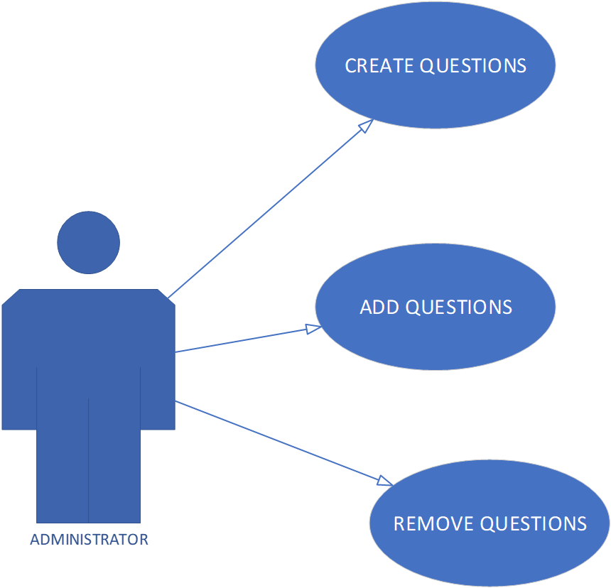

The Administrator creates questions and stores in question bank. For every round the player will get reshuffled questions.



**Our target group for this Game is:**

Kids aged levels between 5 -7 years old. Research suggests children having experiences that involve comparing quantities is very important for biological development, especially between the ages of three or four, up to seven,” says Ann.We have chosen this age group because it is a very crucial learning time for them and

**-**

**Design and Analysis**

Design research

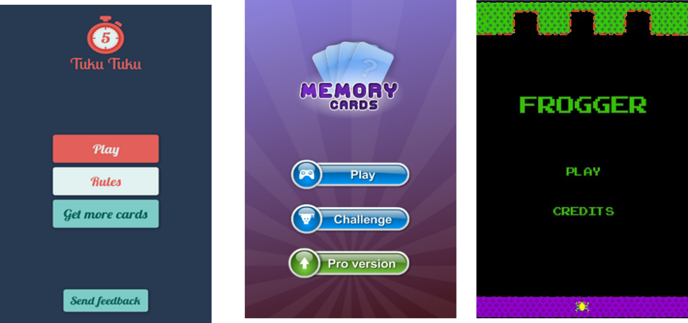

We looked at a lot of different main screen ideas for our app and came across these 3 which we thought looked nice and simple. All these apps have a simple looking GUI with minimal colours used and only2 or 3 buttons. By looking at these designs we thought of using only 2 buttons in the main screen

(Play button & Instructions button). We also thought of adding a picture in the Main Gui so that it doesn’t look dull & boring when kids open the app.

**Wireframes**

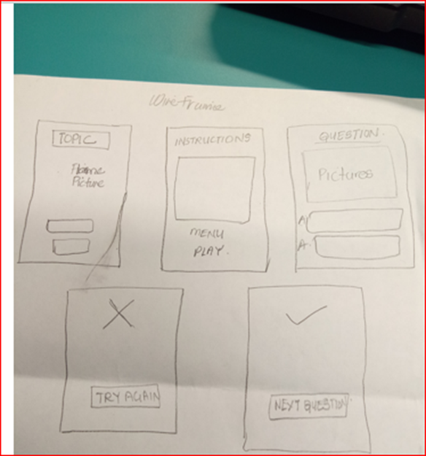

According to Nick Haas (Orbit Media Studios) wireframes are simple black and white layouts that outline the specific size and placement of page elements, site features, conversion areas and navigation for your website.

Wireframes help us to visualize the screen set up of our game. The screen of the question screen will depend on the nature of the question. Wireframe is simply the blueprint of the design. It will help a developer to carry out his work effectively and efficiently. It is just the initial design without functionality.

**Navigation Plan of the Game**



**Improvement after user feedback:**

According to the user’s feedback, the color of the main interface needed to be changed. There was no contrast between the flame and the background color so the whole interface was changed. The “HOW TO PLAY” button removed and replaced with a play icon.

**Game Interface**

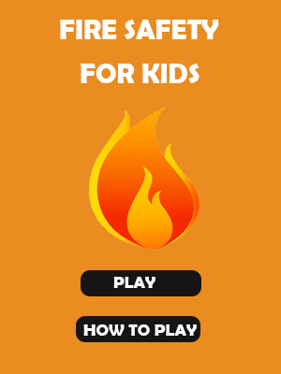

Initially we had this as our main interface, but after user feedback and suggestions we got we changed the interface as below.



This will the main interface of our game.

The player needs to click on the play icon to get the instructions of the game.

After that the player can proceed with game.

**TECHNOLOGY USED**

Android Studio – For developing the game  
  
Photoshop – To style the pictures  
  
YouTube – To look at tutorials on Android Studio

**SOFTWARE METHODOLOGY**

In designing and implementing the mobile game, we are going to use agile methodology. Agile is the best for the software development or application development. This method enables requirements and solutions to achieve effort of the development team.

To create our mobile application, we are going to use the Agile Methodology. Agile methodology will be the best one to use to develop our game because we can work at different phases of the project at the same time. Later in the project if there are any changes we must make, then we can always go back at a previous stage and make those changes. Agile methodology minimizes risks by developing the software in small parts called iterations. Iteration includes all the tasks necessary to release the mini-increment of new functionality: planning, requirements analysis, design, coding, testing, and documentation. At the end of each iteration, the team re-evaluates project priorities.

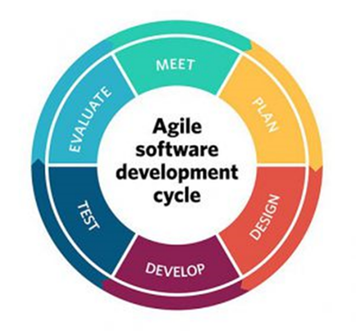

We as a team want to create a mobile application for kids. An application which would make the kids to learn as much and have fun as they play along. We decided the idea of mobile app because a lot of kids these days are on their mobiles. They also like playing games for hours and have fun. Kids don’t learn everything from their teachers at school. They get bored so therefore don’t bother listening. A mobile game would be the ideal solution for little children.

**The Agile Software Development Life Cycle Includes**:

**Planning** - The Project Planning Phase is where the Initial Plan of the Project is discussed. You as a Project Manager would need to make an educated guess of the staff, resources and equipment needed to complete your project.

**Design** – This Phase included making the design of your Project. How the Actual design would look like. The main purpose of this phase is to have the similar look of the application.

**Develop** – This is most arguably the crucial phase of the Project. After the design has been created, It is finally time to implement that design into code. This demands the coding of design into computer language, i.e., programming language. This is also called the programming phase in which the programmer converts the program specifications into computer instructions, which we refer to as programs. We can use C#, C++ , Python or any other suitable language to create the software.

**Testing** – Once the Coding has been finished, then it is time to test the program. Test the program to see if it is functioning properly without any bugs or any problems.

**Evaluation** - Evaluation is the final phase of the Agile SDLC mostly for the sake of discussion. Evaluation takes place during every phase. A key criterion that must be satisfied is whether the intended users are indeed using the system.

**Functionalities of the app**

The app that we are making will be simple and user friendly for kids to access. The aim of the game is to make sure that little kids learn as much as they can about fire safety and have fun as they play along. The game will provide enough information for kids to know about fire safety and what is wrong for them and what is right. The game will consist of 25 questions and each question would have a right answer and a wrong answer. Kids can choose which answer feels right for them. If they have chosen a wrong answer then a message box will appear on screen saying that the answer they’ve chosen is wrong, and it will tell you briefly why it’s wrong. If kids select the right answer then the game will tell that the answer is right, and briefly explain why it’s right. After they select the right answer then they can proceed to the next question and so on. The game will have animations such as flame and kids moving in the background to add a little bit more excitement and thrill in playing the game. The animations would make the game visually appealing and eye catching.

**Team**  
Instead of Splitting Tasks to each team member, we decided to work together as a team and do everything together at the same time. We felt that this way we would get the job done quicker & effectively. In our team, we consisted of Project Manager, Lead Designer, Secondary Designer, Lead Developer and Secondary Developer.

|  |  |
| --- | --- |
| **People** | **Responsibilities** |
| Project Manager. | Project manager is the main individual that ensure that the project is delivering on time. He is the one responsible for taking care of the project. He manages the relationship between client and stakeholders. |
| Designer. | Designer is a person whose job is to gather all the requirements and create the intended design of the app. How the final app would look like. |
| Software Developer. | Software Developer is an individual who works with a team to develop the application with the use of a coding language. They can use any coding language which is suitable for them to create the app. After the deployment of the app, they must test the app to see if there are any bugs and remove them before they can make it public to the customers. |

|  |  |  |  |
| --- | --- | --- | --- |
| **Role** | **Name** | **Email** | **Phone** |
| Project Leader | Anita Devi | Devi424@manukaumal.com | +64223591927 |
| Lead Designer | Anita Devi | Devi424@manukaumal.com | +64223591927 |
| Secondary Designer | Avikash Nand | Nand263@manukaumail.com | +64212614483 |
| Lead Developer | Avikash Nand | Nand263@manukaumail.com | +64212614483 |
| Secondary Developer | Anita Devi | Devi424@manukaumal.com | +64223591927 |

**Risks**

|  |  |  |
| --- | --- | --- |
| Risk | How will it affect? | How can we solve it |
| Limited Time | One of the hurdles which may affect us to complete our project on time is our short period of time. We don’t have much time to develop our software. We are in race against time to complete the project. | We can work twice as hard everyday to make sure we get our assignment done. Even if we don’t complete the whole game, it would still mean a lot to us if we manage to develop most of the game. |
| Not much Experience with Android Studio | We are using Android Studio to develop our game. Me neither my Team member have any experience on using Android Studio. | We can use YouTube to see some tutorials on Android Studio. There are plenty of tutorials on how to create an app. Another option is to use Treehouse.com. That website offers a lot of 1 to 1 tutorials on C#, Html, Java, Game Development, Python and many more. There’s a $25 subscription fee for every month, but it’s going to be worth it because it goes into detail to make sure you learn everything. |
| Work | Due to work and other assignments, it would be hard to focus entirely on the project. This may cause delay and would make it extremely hard to finish the assignment on time. | One thing we can do is to take sick leave from work or negotiate with the boss and work for less hours for a few days so that we get plenty time to focus on the assignment. We can also make time table so that we know what we have to do at what time. This way we would be more organized and would make time out in doing the assignment. |

**Gantt Chart**

A close up of a mans face

Description generated with high confidenceA screenshot of a social media post

Description generated with very high confidence  
This is the initial Gantt Chart for the project. The Gantt chart consist of four phases which we will follow. They are Planning, Design, Implementation & Testing. For Planning we think it’ll take 14 days, Design 6 days, Implementation 13 days & 3 days for Testing. As you can see from the Gantt chart, some activities start when the previous

**Steps in Playing the game**

**Final Game Designs**

**Implementation And Testing**

**Error handling**

When trying to click on the button to navigate through another screen, the game would just crash. The fault was in our method because we didn’t select the right button ID which would open the other interfaces. It was a really simple mistake. We made sure that when button 3 is clicked, It would open the right activity  
  
The layout of the app that we made looked really nice in Android studio , However when we run it to a virtual device , the buttons were everywhere and it looked terrible. I found some difficulty fixing this, but in the end I managed to do it by watching a YouTube video. The solution was simple, all I had to do was to add Constraint _Layout code in all the classes XML file.

We wanted the Main Menu Interface to open first when the game is launched. However the Play screen Interface opens first everytime we run the app. The problem was that we had created the Play Screen Class first therefore it Opens first. By doing a little research we managed to fix it. I went over to the Appmanifest.xml and found there that the play screen activity will launch when the button is clicked. I changed the code so that the Main menu Interface launches first when the button is clicked.  
  
Sound kept playing for long even though we had selected the right answer. To solve this I had to trim the sound down from 5 seconds to 2 seconds. This way the sound didn’t play for too long and whenever user clicks the right answer , the correct sound plays then turns off after 2 seconds.

**Result Analysis  
  
Future Objectives**

* Improve the graphical interface of our game.
* Include more animations.
* Include more pictures in the game.
* Create new scenes in the game.
* Include more pictures for different questions.
* Develop the game in different platforms-IOS, Windows.
* Include different modes in the game eg. Quiz. picture matching, puzzle, spot the hazards and memory games
* Create difficulty levels so that the user can select either beginner, intermediate or advance level.

**Learning Objectives**

We have learnt a lot from this project.

* Learn and use Android Studio from scratch.
* Create interface using Photoshop.
* Report project documentation.
* Write detail project documents.

**Conclusion**

**References**Coding in Flow (11 October 2017). *How to Make a Button Open a New Activity - Android Studio Tutorial* Retrieved from <https://www.youtube.com/watch?v=bgIUdb-7Rqo>

Coding in Flow (17 December 2017). *How to Change the Apps Starting (Default) Activity - Android Studio Tutorial* Retrieved from <https://www.youtube.com/watch?v=6eES56mxfMs>

*Fonts in XML* Retrieved from<https://developer.android.com/guide/topics/ui/look-and-feel/fonts-in-xml.html>

Amir Ali (July 18, 2013) *Add Sound to Your Application in Android Studio* Retrieved from <http://abhiandroid.com/androidstudio/add-audio-android-studio.html>

<https://teamtreehouse.com/library/topic:android>

Tihomir RAdeff(1 March 2017). *Develop simple Quiz in Android Studio* Retrieved from <https://www.youtube.com/watch?v=JA9s_Fntg_4&t=351s>

gilamran (N.D) *simple-layout-js Basic Tutorial* Retrieved from <http://gilamran.github.io/simple-layout-basic-tutorial/>  
  
Skiptis (February 18, 2017). *Simple Game Menu Background Corona Sdk Build A Frogger Inspired Game Interface Creation* Retrieved from <http://80skiparty.com/game-menu-background/simple-game-menu-background-corona-sdk-build-a-frogger-inspired-game-interface-creation/>

(2017). *Flame Clip Art: Flame 7 clip art - vector clip* Retrieved from <http://www.clipartpanda.com/clipart_images/flame-7-clip-art-vector-clip-2520133>

Sabith Pkc Mnr (12 Sep 2016). *Button Click Sound in Android Studio* Retrieved from <https://www.youtube.com/watch?v=RSi959Xyw-Q&t=149s>

Harry (2017). *Plain red blurred background Free Vector* Retrieved from <https://www.freepik.com/free-vector/plain-red-blurred-background_901230.htm#term=plain%20backgrounds&page=1&position=4>